Self-Pay Parking Options near CAMLS

- City of Tampa Interactive Parking Map: https://experience.arcgis.com/experience/ef3dc71c99494d97a204e165c7634226/

- Fort Brooke Parking Garage: Typically $3 per hour with a daily max of $18. Please note, City of Tampa may fluctuate rates on days with city special events.
  - Address: 107 N Franklin St, Tampa, FL 33602
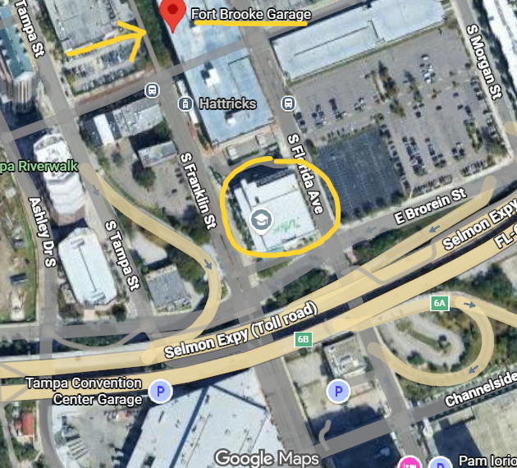

- 717 Levy Lot: Rates vary.
  - Address: 194 S Florida Ave, Tampa, FL 33602
